**Class Git 01. Date; 06-12-2023**

**What is git reset and git revert commands???**

The git reset command is used to undo changes by permanently deleting the commit and history form the repository.

This git reset command remove/delete a specified commit and its history from all the three stages, working directory, staging area and repository permanently.

**Git reset has three types**

* **Git reset --Hard ---------** this command remove the files/directory from all the three stages permanently**.**
* **Git reset –Soft -----------**this command remove the files/directory from repo but it will not remove those files keep the files in working directory and staging area.
* **Git reset --Mixed -------**this command will remove/delete/undo files/directory from repo and staging area but it will not delete those files/directory from working directory.

**What is git revert commands????**

Git revert command is used to undo the changes by creating new commit and preserving the history of the repository.

git revert is a command in Git used to create a new commit that undoes the changes introduced by a previous commit, while preserving the history of the repository.

**What is git??**

git is a version control tool , it was discovered by linus torvalds in 2005.

**What is git-bash;**

it is application or software on which git is used or write or accessed by command line interface.

it was discovered by linus in 2005 for window operating system .

Git was created by Linus Torvalds, the founder of the Linux operating system, in 2005.

**What is UNIX???**

UNIX is a powerful, multiuser, multitasking operating system originally developed in the 1960s and 1970s at Bell Labs.

**What are UNIX style commands???**

UNIX style commands are used to interact with the operating system and perform various tasks.

**What is command line interface???**

Command line interface is a text base interface used to interact with operating system, no GUI involved,

only text based commands.

**What do we need git??? To keep track of our java code.**

1. to saves time
2. to saves memory of computer
3. to prevent being mess due to creation of lot of versions/folder/directories in computer.

**What is version??**

Any change in the code creates its new version.

Updating of an app or tool from previous.

**What is git???**

**global information tracker**; it is version control tool

* Git is a version control tool, that keep tracks all the changes in our code which we made and store them into repository
* **Keep tracking history** Git is used to tracking changes in the source code,
* **Team collaboration** Git enable multiple developers to work together on non-linear development.

**How to communicate with git???**

We communicate with git by text base commands. These are UNIX-style commands.

**Where to give those commands?**

In window we have git bash where we will give these commands.

**Some basic git commands;**

1. **pwd** (Stands for “print working directory”) — Prints out the current directory.
2. **ls** — Lists the files in the current directory list content; hey terminal please tell us what are the files and folder there you are standing at current location.
3. **clear** --- command is used to remove or clear all dashboard.
4. **cd** ---- change directory --🡪 in which directory you want to go.
5. **cd Desktop** --------- >> go to desktop directory and print the names of all the files and folder present there.
6. **cd ..** ----- this is command to go back to previous folder
7. **~ tilde** --- till-da ----- >> is shortcut to go back at home directory.

---------------------------------------------------------------------------------------------------------------------------------------------------

**Class 02 git Date: 07-12-2023**

1. **Why do You need to configure git;**

You need to configure so that because there is repository to enter inside repository there should be user account, security reason so that no one can change you data.

**For accountability** so that you can track who made changes and when made changes in your code, you can ask him question for change.

**For team collaboration** make it easier for team member who is responsible for different parts of the code.

**Security;** if you have user account then only you can change data from that account no one can change delete or remove your data.

**How to configure git?? What are commands to configure git???**

To create user name in git this is the command

1. **git config --global user.name “babarali”**
2. **git config --global user.email “babaraliengineer32@gmail.com”**

When you set up Git for the first time on your computer, it's a good practice to configure some global settings, such as your name and email address.

**To check the global configuration command is:**

**---------------------------------git config --global –list-------------------------------------------------------**

**What is CLI command line interface???**

is an editor where we write commands to interact with computer or software.

1. To make repository use the command ----------- **git init** ----------------------------
2. To save your code into git repository use the following command -----------

**git add .** --------- this command will add your code in staging area

**git commit -m** “message” ------ commit mean --- soapna, amanat ma dena, Azzam

commit mean saving the code into repository

the command to check status of local repository **------- git log** -------------

**how repository works lets understand all the concepts.**

**No lets understand how the git work**

**Let’s understand this diagram.**

1. When you give command --------- git init --------- then
2. a folder with name .git is created inside where java code is present. If you delete the .git folder repository will delete.

**---------------------------------------------------------------------------------------------------------------------------------------**

**Let understand the architecture of git**

Git has three stage of architecture. When a .git folder is created it means internally there three things created.

1. **What is working directory**?

The place where our java files are present?

1. **What is Staging area**?

The place where we add all the files/codes/folder which we want to send the repository ----- at initially empty staging area?

1. **What is Repository??**

Storage which contains all our commits ----------- > initially empty repository.

---------------------------------------------------------------------

What is -------- git status --------- command?

This command tells the status of working directory and staging area.

----------------------------------------------------------------

**What does commit command do???**

1. it gives the name
2. date
3. time
4. username
5. email

**What is commit???**

A "commit" is a snapshot of your project's files when you make a commit, you are essentially creating a record of the changes you've made to your project. Each commit has a unique identifier, typically a long hexadecimal number called a hash that distinguishes it from other commits. Each commit also includes a commit message that describes the purpose of the changes.

**------- Untracked mean ------- files are inside working directory.**

**---**Changes not staged for commit: this mean you have made changes in your code your file is not in staging area it is still inside working directory.

Nothing added to commit but there are untracked files----- mean you do not made

Nothing to commit, working tree clean ----- this means working directory is empty there is nothing.

he message "nothing added to commit" in Git typically appears when you run the **git commit** command, but Git doesn't find any changes to commit in your working directory. This message indicates that there are no new or modified files that Git recognizes as candidates for a commit.

Control + C ---------->> this command is used to cancel current operation which you have done in git.

**Class -03 present inside java class 08 Date;12-10-2023**

**What is GitHub?????**

Central repository over the internet to have backup of code is called GitHub.

1. Suppose your hard disk burnt out in your computer, then your local repository data will also loose. In this case we have a central repository on internet. Just like cloud storage for iPhone, ------google drive ---- for google backup.

**------------------------------------------------------------------------------------**

**Why we should use git hub? What is the importance of that??? What other task you can do by using git hub???**

We can use git to store our code over internet. Git hub is open source software. Gihub can be accessed from anywhere provide remote work.

You can share your code, and can get others code while working in a team project. **Scenario;** Suppose when there was not git hub how you will share your code with other friends who are working at same project inside a company. Then you will use emails, WhatsApp, and other app, it will be very difficult to communicate every time with every member, but if there is github you simply make changes in your code and add comments what you have done, and other team member will watch your code what you have done , and he will start working on his further task or changes on the code.

Now the created repository is git home work on github account. Now how we will make connection with git hub which is present on internet for this we need the URL of that repository.

And go to git bash there use all the commands.

**How you will send code from local to central repository / from git to github.??**

1. First of all create a repository on github.

2. Now you need to make a connection between git local and github central.

3. To make a connection with git and github repository there is a command

------------**git remote add origin url** ---------------- -----------------------

To check that the connection is created between git and github there is command

--------------------------------**git remote -v**-------------------------

--------------**git branch -M main**-----------------send the code in main branch

Now we want to push the code for that there is command

----------------------- **git push -u origin main**------------------------------------------------------

(HEAD -> main, origin/main) ---- >> this mean our local and remote repository are synchronized are at one stage

**Class number 03 Date; 08-12-2023**

**Why we don’t create repository inside the src or .idea or other folder??**

Because if we create the git repository inside any folder like src or idea then git will not be tracked others files like text files, pom.xml files or other files.

**What is git ignore file??**

git ignore file ------ > the files and folder inside the working directory which are not important and that we don’t need to save them inside the repository and they don’t have any purpose to save them inside the repo, ignore all of those files and folder which are not important folder like.

1. out folder -------- this is binary folder we don’t need to add this inside the repository
2. --- .idea folder this folder also don’t need to add in repository.

For above purpose we have a git ignore file.

**how create a git ignore file, what is the command to create git ignore file.????**

**--------------------touch .gitignore --------------- this is the command and a file with the name of .gitignore is created inside the working directory.**

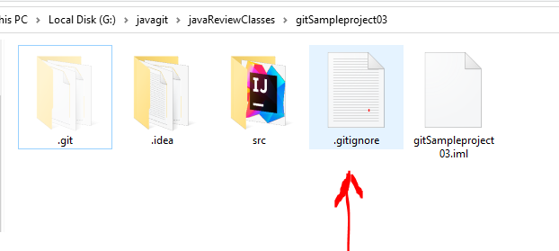

**How you will add file inside the git ignore file??**

1. Open the git ignore file present inside the working directory
2. Then write the names of unnecessary files inside the git ignore file and then save the git ignore file and then

write the name inside git ignore files as ----------/src----/out-----/.idea

After doing of above steps you are going to add. git ignore file inside the repository by command ------- git add . ------

-----------------------------------------------------------------------------------------------

What does it mean un-tracked -------------- >> it means files not stored inside the repository. The red color of files show that the files are inside the working directory.

The green color of files show that the files are inside the staging area. And they need to commit into repository.

---------------------------------------------------------------------------------------------------------------------------------

-------- git ls-files------------------------------this command shows all files inside the staging area.

Above these lines the commands of git have to be remembered, and now next commands you don’t need to remember

=============================================================================================

**Class 4 git Date; 09-12-2023**

**How remove the file if it accidently added in staging area.**

**Scenario;**

1. Suppose you accidently added a file inside the staging area , and now you want to remove this file from staging area
2. To remove this file there is a command in that is -------- git rm --cached filename-----------------

to check all the files in staging area command is-------git ls-**files---------**

**What is head???**

(HEAD -> master) ------ > this head mean pointer/indicator/cursor

-----------------------------------------------------------------------------------------------------------------------------------------------------------

There is another command ----------git diff------------ this command tell the difference in code or files in ‘’staging area’’ and “working directory”. This mean when you change code inside intellij then src file inside the repository tells that modification has been done in src file which is inside the src file which is present inside the working directory. Then --------git diff-------- tell us the difference in file present in working directory and inside the staging area

The status of file between staging area and repo, use the command.

------------------git diff --staged ---------------

**Important command if you accidently delete src folder. Then you can recover it by**

**--------------------git restore src-----------------------foldername**.

**Class 04 date; 12-10-2023**

----enumerating files

What does this command do?????????

----------------------------------------------Git push -u origin main-----------------

Push code local to remote.

------------------------------------------------------------------------------------------------------------------------------------------------------------------------------------------------------------------------------------------------------------------------------------------------------------------

**What is git clone????????**

Clone mean making a copy. a plant or animal that has the same genetics as the original from which it was produced

**What is difference in download and cloning git?????**

Download from github mean it download only one latest or updated file from the github repository, and not download all the files.

Clone mean it download the complete remote repository.

**Why clone is important in git clone?????????**

Scenario; suppose we all working on a project and we need to push and download code into central repository.

There is condition in git repository you only can push the files or code when central repository is empty or when central and local repository are at same level. Or both have same history as we read this already.

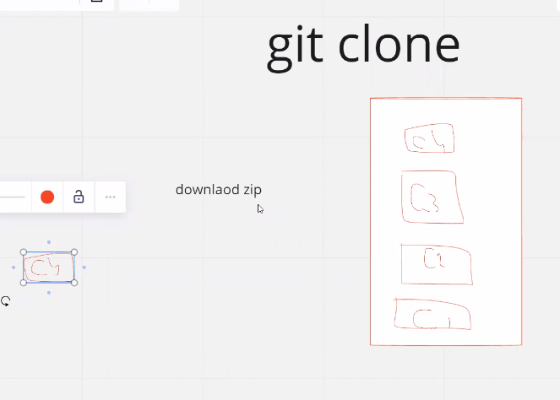

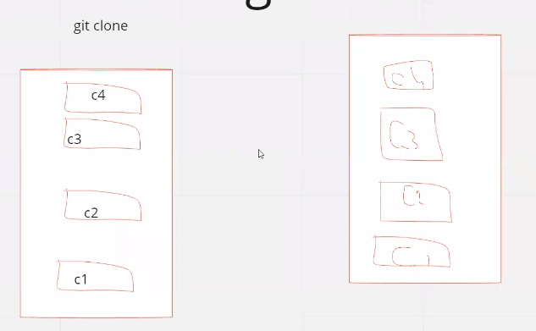



This is example of cloning and downloading.

**What is method to clone git???????**

open your git bash terminal and give a command -------

-------git clone URL/or link of repository-------------------

**What is difference in git pull and git push commands???**

1. --------------git pull--------------to download the changes from remote repository to local repository.

2. --------------git fetch----------this command tells the status of remote repository . is there any update which we need to download.

**Class 05 Date; 11-12-2023**

**What is git stash????** ----------------------------stash mean-------------- >> hide, conceal, store.

Stashing is used to save uncommitted changes in stashing area for temporarily for later use and also it reverts the condition of working directory to the last commit of your local repository.

Git Stash: This is a mechanism that allows you to temporarily save your changes that are not ready to be committed

**Scenario;** is that when you do not want to add changes inside repo, you want first finalized your code and then you want to add this code into repo. The redundant code or unnecessary code you can save inside stash.

3. and this stash command further what also do that , it changes working directory reverted to the state of last commit in the local repo. Simple mean last commit and working directory are at same level.

**Lets understand simple working of stash command.**

-------git stash -m “message”------this is command to save the code in stashing area. **How data bring back from stash storage area????????**



There is a command to check the status of stash -----------git stash list----------------this show what all present ins stash.

to catch back data from stash to working directory there is a command -------git stash apply index number-------------the data in stash will also remain there it will not be deleted.

----------------------------------------------git stash drop --------delete latest commit ---------------------

---------------------------------------------git stash drop 2-------------------it deletes commit index 2 added in stash area.

------------------git stash clear--------to remove all stash

**What is difference in----git stash drop----- and -------git stash pop------- commands??**

Git stash drop delete the latest stash from stashing area. This command just delete the stash.

Git stash pop is used to add the latest stash back into working directory and delete that stash from stashing area. This command get back the stash in working directory and also delete the stash from stash area.

If you specify stash drop 2 it will delete specific stash.

**Class 04 Date:12-12-2023**

----git stash -u--------- this command is used to add untracked(just files inside working directory) files inside stash area. This mean that when the files are only just in working directory and not inside the staging area. Then to make stash the files present in working directory use this command other wise use git stash –m “message”

**When does conflict occur in stash??????** When there is tracked file is present in working directory and your pulling the code from stash area back. It mean you have send the code into repository and now you are getting back a commit from stash then there will be conflict in working directory because there is already code present.

------- untracked mean ------- files which are inside working directory.----red in color

-------if you want to stash untracked files -------git stash -u “message”-----command is used.

--------tracked files mean---------the files which are in staging area-------

--------to stash tracked files what is command------git stash -m “message”-------- this is for stash tracked files.

Yes, the stash area in Git is preserved across Git sessions as long as you do not perform any actions that explicitly remove or clear the stash. If you stash changes using ----**git stash save-----** and then close Git Bash or exit your terminal, the stash will still be available when you open Git Bash again in the same repository.

---------------------------------------------------------------------------------------------------------------------------------------------------------------------------------------------------------------------------------------------------------------------------------------------------------------------------------------

Is we create a new remote repository for every local repository????????

Its your own choice, you can create a single remote repo for many local repository.

Or you can have one to one repo , mean for every local repo, every remote separate repo.---------------------------------------------------------Clone the project --------------------------------------------------------------

Scenario; is , there are two persons which are working of car project they have clone repository of same project in theirs pc.

They asked the leader hey send us the link of car project. He send the link of github repository. Both team member clone from that link.

(HEAD -> master, origin/master, origin/HEAD) ---- >> this mean local and remote are at same level are synchronized.

------------------------------git fetch--------------command is used to tell that there are update on remote repo or not.

Updates will shown for that user who will submit file in remote later. Who will be on 2nd position.

-

-------------git pull------------------------is used to download any update from remote repo to local repo

**When should use stash useful??**

But remember stash is useful only when the file has not committed. But in this case file is committed

**Class 05 date;13-12-2023**

**What is a git branch???**

Branch is a new separate version of your commit from which the branch was created.

**In git why do we need branch?????**

**We need Branches** so that **we can** work on project without impacting the main **branch**.

----------------------------------------------------------------------------------------------------------------------

**Scenario**; suppose main branch ------- > has facebook production code-------- > and mark Zuckerberg hires a developer to update an emoji in facebook. Now tell what the developer will work on main branch or he create the new branch ---------- the copy of main branch to update the emoji. Because may be during update of emoji the other code of facebook in main branch get affected. Billions of dollars lose.

The other features of facebook may disable. to overcome this issue that’s why we need branch.

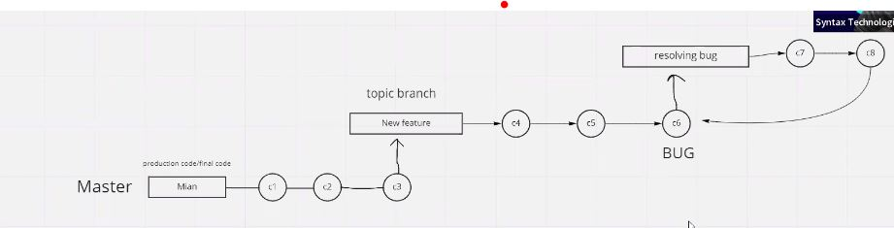

(HEAD -> main, origin/main)🡪> this line mean , local repo and remote repo are synchronized. Main branch of local repo and main branch of origin repo are at same commit

**how create a branch in repo ?????????**

The command to create a branch is -------------------git branch sun--------------sun is name you can choose any name

But when you want to rename the branch then ----------git branch -M main----------here -M is used for rename the branch .

**How to switch the branch??????**

We are in local main branch, now we want to switch from local main branch to topic sun branch----------------------------------------------------------git switch sun------------------To switch from branch to branch command is ------------

-----git checkout sun---------sun is name of branch.

**How to check in which branch we are present????????**

The command for checking the branch is ----------git branch----------------------show the working branch.

Now I want to create another branch from sun branch or topic branch.

**How can merge branch????????**

1. you want to merge bug fix branch with sun branch.

2. go to sun branch and there type a command to merge bug fix command with sun branch the command is

-----------------------------git merge bugfix--------------------------

What is command to delete a branch ??????

-------------------------------------------------------------------------git branch -d BugFix-------------------this will delete branch..

**Whenever we have new branch on git hub and we want those branches in local,**

**To download branches from github there is command as that we have to do?????**

-------------------------------**git branch -a-----------------------------** command is used to list all branches in a Git repository, including both local and remote branches. The **-a** flag stands for "all."

When you run this command, you'll see a list of branches in your repository. Local branches are prefixed with **\***, and remote branches are listed with the remote name (such as **origin/branch_name**). Here's an example output:

---------git branch -a--------- this command will show you all the branches in git hub.

To download a branch from the list.

----------Switch to that branch---------------------git switch planet01---------------this command will download for you branch with name planet01.

-----git pull-------- does not download all branches it just update the current branch.

Class 06 date;16-12-2023

**What is fast forward merge????**

**This is the strategy which git uses to merge the branches.**

When fast forward merge occurs??

When there is no change in parent branch from which a child branch is created and you are merging the child branch into parent branch this is called fast forward merge.

It is occur then no changes has been made inside the branch from which a new branch has been created. And new commit is added back to parent commit this is fast forward strategy.

Not: if there is no fast forward merge it is not necessary that there will be conflict. Conflict only occurs when there is change in the same line by developer one and also developer 2.

**What is Three-way merge or recursive merge??**

Three way strategy is used when there is change in parent commit from which a child branch has been created, and some one other added his code in parent branch. Now there is update and you do not add his code. That’s why three way merge is used.

When there is conflict between the code then there use a cursive merge technique.

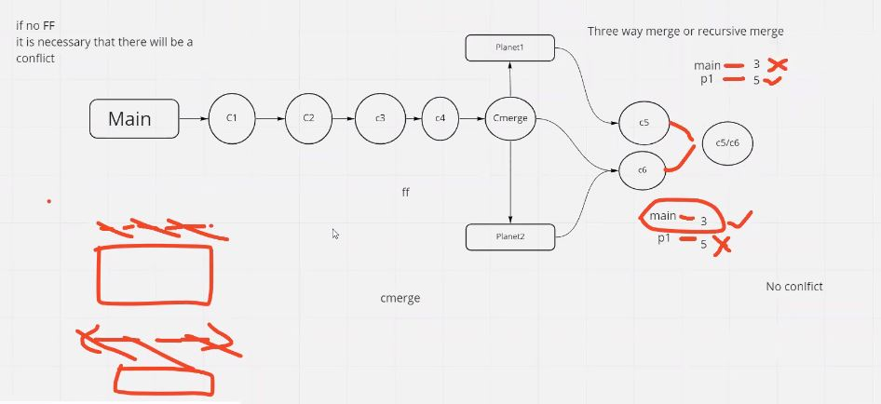

A three-way merge is a merging strategy used by Git when combining changes from two different branches. It involves three commits:

1. **The common ancestor commit (the base):** This is the commit from which both branches diverged. It serves as a reference point to identify the changes made on each branch.
2. **The current branch's commit (ours):** The changes made on the branch where the merge is being initiated.
3. **The other branch's commit (theirs):** The changes made on the branch that is being merged into the current branch.

Git compares the changes introduced in the "ours" and "theirs" commits relative to the common ancestor to automatically merge the changes. In cases where changes do not conflict, Git can perform an automatic merge. However, when conflicting changes are detected (i.e., changes made in both branches that overlap), Git requires manual intervention to resolve the conflicts.

The **git pull** command is used to fetch changes from a remote repository and integrate those changes into the current branch. It's a combination of two commands: **git fetch** and **git merge**.

------------------------git pull origin master-----------------------

* + This command is used to update your local repository with changes made by others. It's often used when you're working on a branch, and you want to incorporate the latest changes from the remote repository into your local branch.

In summary, **git clone** is used to create a local copy of a remote repository, while **git pull** is used to update your local repository with changes from a remote repository. They serve different purposes in the Git workflow.

**What is difference in fetch and pull commands??????**

Fetch command show the any update in remoter repo and pull is used to download those updates in your local and merge them in your working branch.

When same lines changed by two different person then conflict occur. When conflict happen occur?

When you want to delete the commit use following commands